**Tugas TIK Selasa, 02 Agustus 2022**

Kerjakanlah tugas berikut dengan benar jawaban dikumpulkan pada Assignment Kiss.

1. Tentukanlah Notasi Boolean dan Tabel Kebenaran dari Diagram berikut : **(20 Point)**  
   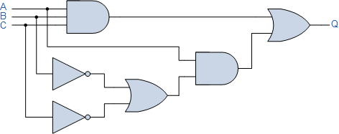
2. Tentukanlah Notasi Boolean dan Tabel Kebenaran dari Diagram berikut : **(20 Point)**  
   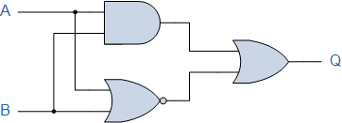
3. Dari Notasi Boolean Berikut, tentukanlah Tabel Kebenarannya : **(60 Point)**
   1. A.B + B.A (AC) **(20 Point)**
   2. CD.DC + AB.ED **(20 Point)**
   3. (M+N)+(PQ) **(20 Point)**

**Jawaban :**

1. Notasi Boolean   
   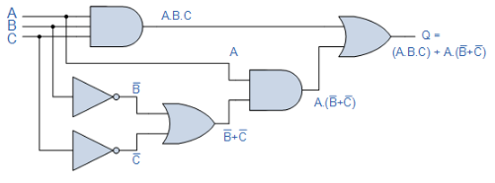  
     
   Tabel Kebenaran :  
   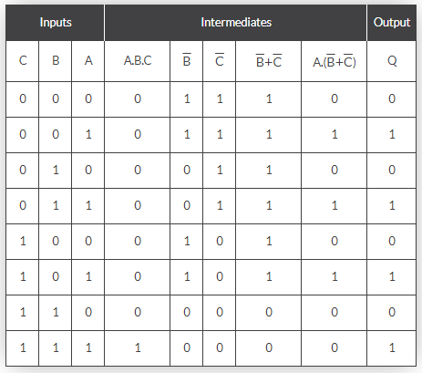
2. Notasi Boolean  
   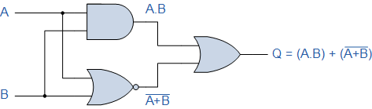  
   Tabel Kebenaran :   
   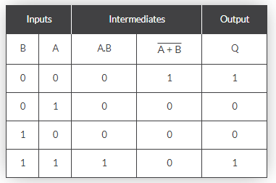
3. Menentukan Tabel Kebenaran dari Notasi Boolean :
   1. A.B + B.A (AC) **(20 Point)**

|  |  |  |  |  |  |  |  |  |
| --- | --- | --- | --- | --- | --- | --- | --- | --- |
| **A** | **B** | **C** | **D** | **AC** | **AB** | **BA** | **AB+BA** | **A.B + B.A (AC)** |
| 0 | 0 | 0 | 0 | 0 | 0 | 0 | 0 | 0 |
| 0 | 0 | 0 | 1 | 0 | 0 | 0 | 0 | 0 |
| 0 | 0 | 1 | 0 | 0 | 0 | 0 | 0 | 0 |
| 0 | 0 | 1 | 1 | 0 | 0 | 0 | 0 | 0 |
| 0 | 1 | 0 | 0 | 0 | 0 | 0 | 0 | 0 |
| 0 | 1 | 0 | 1 | 0 | 0 | 0 | 0 | 0 |
| 0 | 1 | 1 | 0 | 0 | 0 | 0 | 0 | 0 |
| 0 | 1 | 1 | 1 | 0 | 0 | 0 | 0 | 0 |
| 1 | 0 | 0 | 0 | 0 | 0 | 0 | 0 | 0 |
| 1 | 0 | 0 | 1 | 0 | 0 | 0 | 0 | 0 |
| 1 | 0 | 1 | 0 | 1 | 0 | 0 | 0 | 0 |
| 1 | 0 | 1 | 1 | 1 | 0 | 0 | 0 | 0 |
| 1 | 1 | 0 | 0 | 0 | 1 | 1 | 1 | 0 |
| 1 | 1 | 0 | 1 | 0 | 1 | 1 | 1 | 0 |
| 1 | 1 | 1 | 0 | 1 | 1 | 1 | 1 | 1 |
| 1 | 1 | 1 | 1 | 1 | 1 | 1 | 1 | 1 |

* 1. CD.DC + AB.ED **(20 Point)**

|  |  |  |  |  |  |  |  |  |  |  |  |
| --- | --- | --- | --- | --- | --- | --- | --- | --- | --- | --- | --- |
| **A** | **B** | **C** | **D** | **E** | **CD** | **DC** | **CD.CD** | **AB** | **ED** | **AB.ED** | **CD.DC + AB.ED** |
| 0 | 0 | 0 | 0 | 0 | 0 | 0 | 0 | 0 | 0 | 0 | 0 |
| 0 | 0 | 0 | 0 | 1 | 0 | 0 | 0 | 0 | 0 | 0 | 0 |
| 0 | 0 | 0 | 1 | 0 | 0 | 0 | 0 | 0 | 0 | 0 | 0 |
| 0 | 0 | 0 | 1 | 1 | 0 | 0 | 0 | 0 | 1 | 0 | 0 |
| 0 | 0 | 1 | 0 | 0 | 0 | 0 | 0 | 0 | 0 | 0 | 0 |
| 0 | 0 | 1 | 0 | 1 | 0 | 0 | 0 | 0 | 0 | 0 | 0 |
| 0 | 0 | 1 | 1 | 0 | 1 | 1 | 1 | 0 | 0 | 0 | 1 |
| 0 | 0 | 1 | 1 | 1 | 1 | 1 | 1 | 0 | 1 | 0 | 1 |
| 0 | 1 | 0 | 0 | 0 | 0 | 0 | 0 | 0 | 0 | 0 | 0 |
| 0 | 1 | 0 | 0 | 1 | 0 | 0 | 0 | 0 | 0 | 0 | 0 |
| 0 | 1 | 0 | 1 | 0 | 0 | 0 | 0 | 0 | 0 | 0 | 0 |
| 0 | 1 | 0 | 1 | 1 | 0 | 0 | 0 | 0 | 1 | 0 | 0 |
| 0 | 1 | 1 | 0 | 0 | 0 | 0 | 0 | 0 | 0 | 0 | 0 |
| 0 | 1 | 1 | 0 | 1 | 0 | 0 | 0 | 0 | 0 | 0 | 0 |
| 0 | 1 | 1 | 1 | 0 | 1 | 1 | 1 | 0 | 0 | 0 | 1 |
| 0 | 1 | 1 | 1 | 1 | 1 | 1 | 1 | 0 | 1 | 0 | 1 |
| 1 | 0 | 0 | 0 | 0 | 0 | 0 | 0 | 0 | 0 | 0 | 0 |
| 1 | 0 | 0 | 0 | 1 | 0 | 0 | 0 | 0 | 0 | 0 | 0 |
| 1 | 0 | 0 | 1 | 0 | 0 | 0 | 0 | 0 | 0 | 0 | 0 |
| 1 | 0 | 0 | 1 | 1 | 0 | 0 | 0 | 0 | 1 | 0 | 0 |
| 1 | 0 | 1 | 0 | 0 | 0 | 0 | 0 | 0 | 0 | 0 | 0 |
| 1 | 0 | 1 | 0 | 1 | 0 | 0 | 0 | 0 | 0 | 0 | 0 |
| 1 | 0 | 1 | 1 | 0 | 1 | 1 | 1 | 0 | 0 | 0 | 1 |
| 1 | 0 | 1 | 1 | 1 | 1 | 1 | 1 | 0 | 1 | 0 | 1 |
| 1 | 1 | 0 | 0 | 0 | 0 | 0 | 0 | 1 | 0 | 0 | 0 |
| 1 | 1 | 0 | 0 | 1 | 0 | 0 | 0 | 1 | 0 | 0 | 0 |
| 1 | 1 | 0 | 1 | 0 | 0 | 0 | 0 | 1 | 0 | 0 | 0 |
| 1 | 1 | 0 | 1 | 1 | 0 | 0 | 0 | 1 | 1 | 1 | 1 |
| 1 | 1 | 1 | 0 | 0 | 0 | 0 | 0 | 1 | 0 | 0 | 0 |
| 1 | 1 | 1 | 0 | 1 | 0 | 0 | 0 | 1 | 0 | 0 | 0 |
| 1 | 1 | 1 | 1 | 0 | 1 | 1 | 1 | 0 | 0 | 0 | 1 |
| 1 | 1 | 1 | 1 | 1 | 1 | 1 | 1 | 1 | 1 | 1 | 1 |

* 1. (M+N)+(PQ) **(20 Point)**